Stride and Padding
Number of pixels that you move the filter is called stride. Stride can take any value.
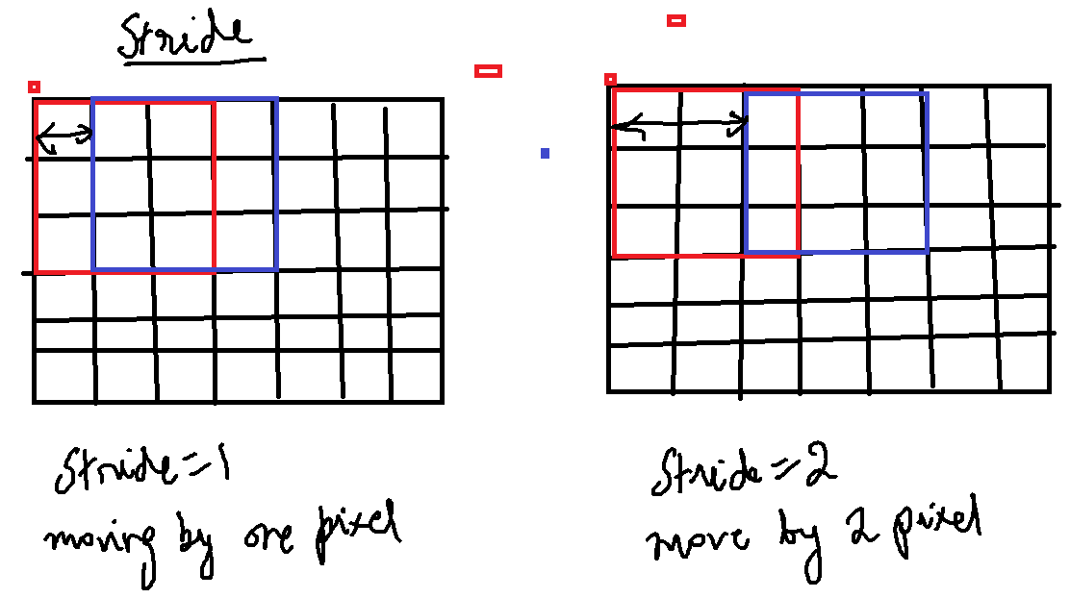

Padding of ‘x’ means that ‘x’ units of rows/columns are added all around the image. Convolution without padding reduces the size.
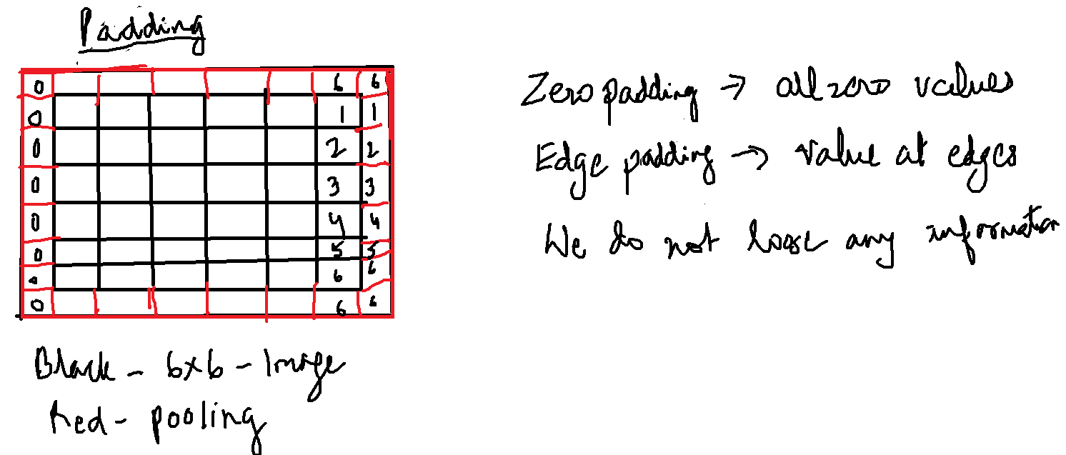

You cannot convolve any size of image with any size of filter. You cannot convolve 5*5 image with a 2*2 filter.

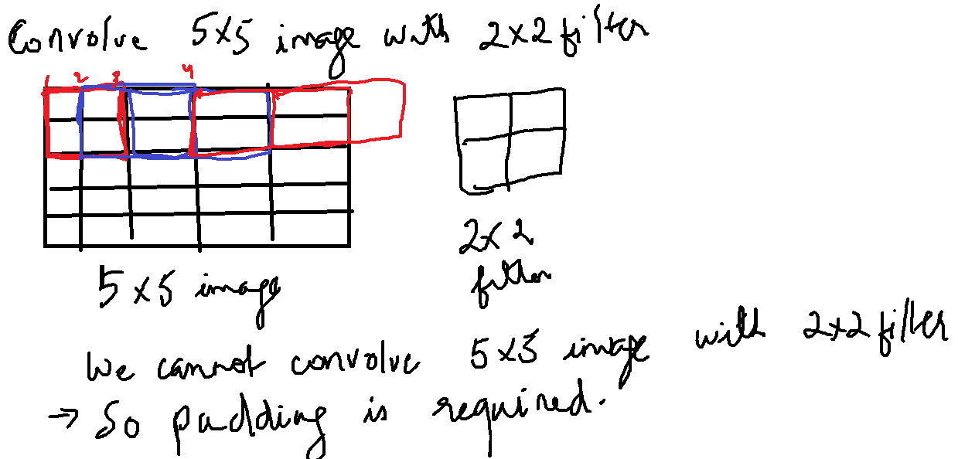

Size of Output
Image – n*n (6*6)
Filter – k*k (3*3)
Padding – p (0)
Stride – s (1)

Output size = ((n+2p-k)/s)+1, ((n+2p-k)/s)+1
= ((6+2*0-3)/1)+1 , ((6+2*0-3)/1)+1

= ((3)/1)+1, ((3)/1)+1

= 4,4

Weight Of CNN:
Black and white images are 2d arrays.
Color images are 3d arrays. Third channel is for color. Red, green, blue are primary colors. Color images will use 3d filters.

These filters are learned during training. Each individual value of a filter is a weight. The filters can have bias associated with each filter. A neuron is basically a filter whose weights are learned during training. So 3*3 filter will have nine weights.

Feature Map:
Multiple neurons are used to convolve an image to generate a feature map. Output of convolution and activation function generates a feature map.

